MAJOR PROJECT REPORT

ON

INTERNSHIP PROJECT
CREATE A TO-DO LIST USING HTML PROGRAMMING LANGUAGE

IN THE DOMAIN OF
FRONT-END WEB DEVELOPMENT

BY
ANANYA MAURYA

DATE: 24-08-2025

TABLE OF CONTENTS
S. No | Topic | Page no.
1. | Abstract | 3
2. | Objectives | 4
3. | Introduction | 6
4. | Methodology | 9
5. | Code | 11
6. | Results and Outputs | 15
7. | Conclusion | 20

ABSTRACT
This project report details the design, development, and implementation of "CLARITY TO-DO LIST," a comprehensive and dynamic task management application built using a powerful combination of front-end web technologies: HTML5, CSS3, Bootstrap, JavaScript, and the jQuery library. The fundamental objective of this project is to provide users with a seamless, intuitive, and highly functional platform for organizing their daily tasks, thereby enhancing personal and professional productivity. The application supports all essential task management functionalities, including the ability to add new tasks, view an organized list of existing tasks, edit the details of any task, and mark tasks as complete, which removes them from the active list.
The application's front-end architecture is built upon a foundation of semantic HTML5, which provides a logical and accessible structure for all user interface elements, including the main task display table and the data entry forms. This structure is further enhanced by the Bootstrap framework, which is leveraged extensively to ensure a fully responsive design that adapts gracefully across a multitude of devices, from large desktop monitors to tablets and smartphones. Bootstrap's pre-styled components, such as modals for task entry and editing, a responsive navigation bar, and styled tables, significantly accelerated the development process while ensuring a clean, modern, and consistent visual aesthetic.
The core logic and interactivity of the "CLARITY TO-DO LIST" are powered by JavaScript, which handles all client-side operations. The integration of the jQuery library streamlines this process by simplifying complex Document Object Model (DOM) manipulation and event handling. This enables dynamic functionalities critical to the user experience, such as the real-time addition, editing, and deletion of tasks without requiring a full page reload. User inputs are captured from modal forms, processed into structured data objects, and used to dynamically update the UI, creating a fluid and highly interactive workflow for the user.
A key feature of this application is its implementation of data persistence through the browser's localStorage API. This client-side storage mechanism allows user tasks to be securely saved directly on their own device as a JSON string. As a result, all entered tasks are retained across browser sessions, even after closing the tab or restarting the computer. This approach ensures data integrity and reliability for the user without the complexity and overhead of a server-side database, making the application lightweight, portable, and immediately functional. In synthesis, the "CLARITY TO-DO LIST" project successfully combines HTML for structure, Bootstrap for responsive styling, and JavaScript with jQuery for dynamic behavior and logic. The result is a robust, feature-rich, and user-centric to-do list application that offers a powerful yet simple solution for effective task management, empowering users to bring order and clarity to their daily responsibilities.

OBJECTIVE
The following objectives are taken into account while Creating a To Do list using the HTML Programming Language:
- User-Friendly Interface
- Accessibility
- Responsive Design
- Clear Task Representation
- Task Management Functionalities
- Data Persistence
1) User-Friendly Interface:
The foremost objective in designing a To-Do list using HTML is to craft a user-friendly interface that fosters intuitive interaction and effortless navigation. Users should seamlessly engage with the list, effortlessly adding, editing, and deleting tasks with minimal friction. Achieving this entails employing clear visual cues, intuitive controls from the Bootstrap framework, and logical layout organization to enhance usability. By prioritizing simplicity and efficiency in design, users can effectively manage their tasks without unnecessary cognitive load, resulting in a more satisfying and productive user experience.

2) Accessibility:
An essential objective when creating a To-Do list using HTML is to prioritize accessibility, ensuring that all users, including those with disabilities, can effectively engage with the interface. This involves employing semantic HTML elements to structure content in a meaningful way, aiding screen readers in accurately interpreting and conveying information. Additionally, providing alternative text for non-text elements, such as images or icons, enables users relying on assistive technologies to comprehend and navigate the interface seamlessly. By adhering to accessibility best practices, such as implementing keyboard navigation and ensuring sufficient color contrast, the To-Do list becomes inclusive, empowering all users to manage their tasks independently.

3) Responsive Design:
A crucial objective in crafting a To-Do list using HTML and Bootstrap is to implement responsive design principles, enabling the interface to adapt seamlessly to diverse screen sizes and devices. By prioritizing responsiveness, users can access and manage their tasks effortlessly across various platforms, including desktop computers, tablets, and smartphones. This entails utilizing Bootstrap's fluid layouts, flexible grids, and media queries to dynamically adjust the layout and content presentation based on the device's screen dimensions. By embracing responsive design, the To-Do list becomes accessible and user-friendly across a wide range of devices, empowering users to stay organized and productive regardless of their preferred device or screen size.

4) Clear Task Representation:
A fundamental objective in designing a To-Do list is to ensure clear task representation, enhancing user comprehension and organization. Each task should be distinctly presented in a structured table, incorporating essential details such as the task name, the responsible person, and the estimated time of completion (ETA). Employing styling techniques to differentiate between tasks enhances visual clarity, aiding users in swiftly identifying their current progress and remaining obligations. By prioritizing clear task representation, the To-Do list optimizes user productivity and satisfaction, fostering a streamlined and efficient task management experience.

5) Task Management Functionalities:
A pivotal objective in developing a To-Do list is to furnish essential task management functionalities that facilitate seamless organization and productivity. This encompasses incorporating features such as adding new tasks, marking tasks as complete (removing them), editing existing tasks, and deleting tasks, ensuring they are easily accessible and intuitively usable. The addition and editing of tasks should be a straightforward process, managed through modal dialogs that provide a clear and intuitive interface. These functionalities should be readily accessible through intuitive controls, such as buttons and icons, ensuring a frictionless user experience.

6 ) Data Persistence:
A critical objective is to implement robust data persistence mechanisms, ensuring that users' tasks are reliably saved and accessible across sessions. This involves implementing a mechanism to store task data securely, so users can seamlessly resume task management activities even after refreshing the page or closing the browser. This project achieves data persistence by leveraging the local storage capabilities provided by modern web browsers. Using local storage allows task data to be stored directly on the user's device, enabling quick and efficient access without the need for server communication. This enhances the reliability and usability of the application.
INTRODUCTION
In the contemporary digital era, individuals are perpetually inundated with a torrent of information, commitments, and responsibilities stemming from both their personal and professional lives. This phenomenon, often referred to as cognitive overload, presents a significant challenge to maintaining focus, organization, and productivity. The traditional methods of task management, such as pen-and-paper lists, while timeless, often lack the flexibility, accessibility, and dynamic capabilities required to keep pace with the fluid nature of modern workflows. In response, a vast ecosystem of digital productivity tools has emerged. However, many of these solutions are either overly complex, laden with features that overwhelm the user, or are tethered to proprietary platforms that require subscriptions and constant internet connectivity. This creates a distinct need for a task management solution that is simple, accessible, powerful, and respects user autonomy.
This project report details the conceptualization, design, and implementation of "CLARITY TO-DO LIST," a web-based task management application engineered to address this very need. The core vision behind this project is to provide a clean, intuitive, and frictionless interface that serves as a direct conduit between a user's thoughts and their organized actions. "CLARITY TO-DO LIST" is intentionally designed as a purely client-side application. This fundamental architectural decision means that the entire application runs directly within the user's web browser, requiring no backend server, no user accounts, and no mandatory internet connection after the initial page load. This approach not only ensures lightning-fast performance and offline functionality but also guarantees user privacy, as all task data remains securely on the user's local machine. The application empowers users with the essential functionalities of modern task management: the ability to seamlessly add new tasks, view all pending items in an organized and legible format, edit the details of any task on the fly, and mark tasks as complete to remove them from the active list.
To achieve this vision, a carefully selected stack of robust and proven front-end technologies was employed, with each component playing a distinct and critical role in the application's architecture. The synergy between these technologies—HTML5, CSS3, the Bootstrap framework, JavaScript, and the jQuery library—forms the foundation upon which "CLARITY TO-DO LIST" is built. This introduction will serve to dissect the role and significance of each of these technological pillars.
Architectural Components and Technological Choices
1. HTML5: The Structural Foundation
At the very core of the application lies HTML5 (HyperText Markup Language 5), which provides the essential structure and semantic meaning for all the content presented to the user. Far from being a mere container for text, semantic HTML5 is used as the architectural blueprint of the application. Elements such as <nav>, <main>, <section>, and <button> are used to define the different regions of the user interface, which not only aids in code organization and maintainability but also significantly improves accessibility for users relying on screen readers. The primary display of tasks is structured within a <table> element, with <thead> for headers and <tbody> for the dynamically generated task rows (<tr>). For user input, <form> elements are utilized within modal dialogs, containing various input types like <textarea> for detailed descriptions and <input type="datetime-local"> for precise deadline tracking. This deliberate use of semantic markup ensures that the application is not only well-structured for the developer but also meaningful and navigable for all users.
2. CSS3 & Bootstrap 5: The Visual and Responsive Design Layer
While HTML provides the skeleton, the aesthetic appeal, visual hierarchy, and, most critically, the responsive layout are governed by CSS3 (Cascading Style Sheets 3) and the Bootstrap 5 framework. Bootstrap was chosen as the primary design framework for its comprehensive library of pre-styled components and its powerful "mobile-first" responsive grid system. This choice dramatically accelerated the development process and ensured a consistent, professional appearance across the application.
The 12-column grid system is fundamental to the application's responsive nature, allowing the layout to fluidly adapt to different screen sizes, from a wide desktop monitor to a narrow mobile phone screen. Key Bootstrap components are leveraged throughout the application: the <nav> element is styled into a responsive navbar, user input is handled through elegant modal dialogs that overlay the main content, and user actions are triggered by styled buttons and icons. Custom CSS styles are then layered on top of the Bootstrap framework to apply a unique color scheme and branding to "CLARITY TO-DO LIST," creating a distinct visual identity while retaining the robust, cross-browser compatible foundation that Bootstrap provides.
3. JavaScript: The Dynamic Engine
JavaScript is the central nervous system of the application, transforming the static HTML structure into a living, interactive experience. As the primary programming language of the web, JavaScript is responsible for implementing all of the application's logic and dynamic behavior. The core functionalities—adding, editing, and removing tasks—are all handled by custom JavaScript functions. These functions perform critical tasks such as:
- Event Handling: Listening for user actions, such as a click on the "Add Task" button or the "Edit" icon.
- DOM Manipulation: Dynamically creating, modifying, and deleting HTML elements in real-time. When a user adds a new task, it is JavaScript that generates a new table row (<tr>) and appends it to the task list without requiring a page refresh.
- Data Management: Managing the array of task objects that represents the user's to-do list, including adding new objects, updating existing ones, and filtering out completed tasks.
- Interacting with Browser APIs: Communicating with the browser's localStorage to save and retrieve task data.
4. jQuery: The Productivity Accelerator
While modern "vanilla" JavaScript is incredibly powerful, the jQuery library was incorporated into this project to streamline and simplify client-side scripting. jQuery provides a more concise and elegant syntax for common JavaScript tasks, particularly DOM manipulation and event handling. Instead of writing verbose document.querySelector() statements, jQuery allows for a powerful and chainable selector syntax ($()). This simplification leads to code that is often easier to read, write, and maintain, reducing development time and minimizing the potential for errors. For this project, jQuery is instrumental in easily selecting form elements to serialize their data, toggling the visibility of Bootstrap modals, and dynamically updating the HTML of the task table with a single line of code.
5. localStorage: The Client-Side Memory
Perhaps the most crucial feature for ensuring the practical usability of "CLARITY TO-DO LIST" is its mechanism for data persistence, which is achieved using the browser's localStorage API. localStorage is a key-value storage system that allows web applications to store data persistently on a user's computer with no expiration date. In this application, the entire array of task objects is converted into a JSON (JavaScript Object Notation) string using JSON.stringify(). This string is then saved in localStorage under a single key. When the user revisits the application, the JavaScript code retrieves this JSON string, parses it back into a JavaScript array using JSON.parse(), and uses this data to reconstruct the user's task list. This simple yet powerful technique ensures that the user's data is always preserved across sessions, providing the reliability expected of a modern productivity tool.
In summary, this project represents a holistic integration of foundational web technologies to create a complete, functional, and user-centric application. The following sections of this report will provide a detailed exploration of the methodology, code implementation, and final output of "CLARITY TO-DO LIST," demonstrating how these components were woven together to build a truly effective task management solution.

METHODOLOGY
When creating a To-Do list using HTML, CSS, JavaScript (JS), jQuery, and Bootstrap, it's essential to adopt a structured methodology to ensure efficiency, maintainability, and user satisfaction throughout the development process. Here's a detailed overview of the methodology considered:
Requirement Analysis:
This is the foundational stage where the project's goals and user needs are comprehensively understood. It involves defining the core features: task addition, editing, and deletion. The target audience is general users who need a simple tool for task management. User personas range from students organizing study schedules to professionals managing work assignments. Understanding these needs helps tailor the application to be intuitive and efficient for its intended users. Responsiveness is a key requirement to ensure usability across desktops, tablets, and mobile devices.
Wireframing and Prototyping:
In this phase, visual representations of the user interface are created. Wireframes serve as skeletal outlines, depicting the layout and structure of the To-Do list. They help visualize the hierarchy of content, such as the placement of the main task table, the "Add Task" button, and the structure of the input modals. Prototypes are then developed as interactive representations, allowing stakeholders to simulate interactions like clicking buttons and filling out forms. This iterative process helps refine the user experience and ensures the final design is intuitive and easy to use.
Responsive Design Planning:
The primary objective here is to ensure the application is accessible and user-friendly across a wide range of devices. To achieve this, Bootstrap's grid system and responsive utility classes are used. Bootstrap offers a flexible 12-column layout, allowing the creation of responsive designs that adapt seamlessly to different screen sizes. By utilizing grid classes like col-sm-*, col-md-*, and col-lg-*, the layout of the task list is defined to ensure content is appropriately sized and positioned across all devices.
HTML Structure:
In this phase, a well-organized and semantically meaningful HTML structure is constructed based on the wireframes. Semantic HTML elements are utilized to enhance clarity and accessibility.
The To-Do list HTML structure comprises several key sections:
- Navigation Bar: A top-level bar containing the application logo and title, built using Bootstrap's <nav> component.
- Main Container: This section holds the core application content, including the control buttons and the task display area.
- Task Display Section: Here, existing tasks are displayed in a Bootstrap table (<table>). Semantic elements like <thead> and <tbody> are used to structure the list of tasks, with each task represented as a table row (<tr>).
- Modals: Bootstrap modals are used for adding and editing tasks. These modals contain <form> elements with <input> and <textarea> fields for task details, providing a focused user interface for data entry.
CSS Styling:
In this phase, the objective is to enhance the visual appearance and usability of the application. While Bootstrap provides a solid foundation with its predefined styles, custom styles are applied to align with the application's branding. The background colors of the body (#367da8) and the main container (#e780df) are customized to create a unique look and feel. Bootstrap's utility classes for spacing, typography, and color are used extensively to ensure a consistent and modern design with minimal custom CSS.
JavaScript Functionality:
This phase involves implementing the dynamic interactions and task management features of the application using JavaScript and jQuery. jQuery is used to simplify DOM manipulation and event handling.
The JavaScript functionality includes:
- Task Addition: A function addTask() captures user input from the "Add Task" modal, creates a new task object, and appends it to an array stored in the browser's local storage.
- Task Display: The createHtmlfromStorage() function retrieves the task array from local storage, dynamically generates HTML table rows for each task, and injects them into the task table body. This function is called on page load and after any modification to the task list.
- Task Manipulation: Functions editTask() and markAsDone() handle user actions. editTask() populates the "Edit Task" modal with the selected task's data, while markAsDone() removes a task from the local storage array.
- Task Update: The updateTask() function takes the edited data from the modal, updates the corresponding task object in the local storage array, and refreshes the display.
- Event Handling: Event listeners are attached to buttons and icons to trigger the corresponding JavaScript functions, creating a responsive and interactive user experience.

CODE

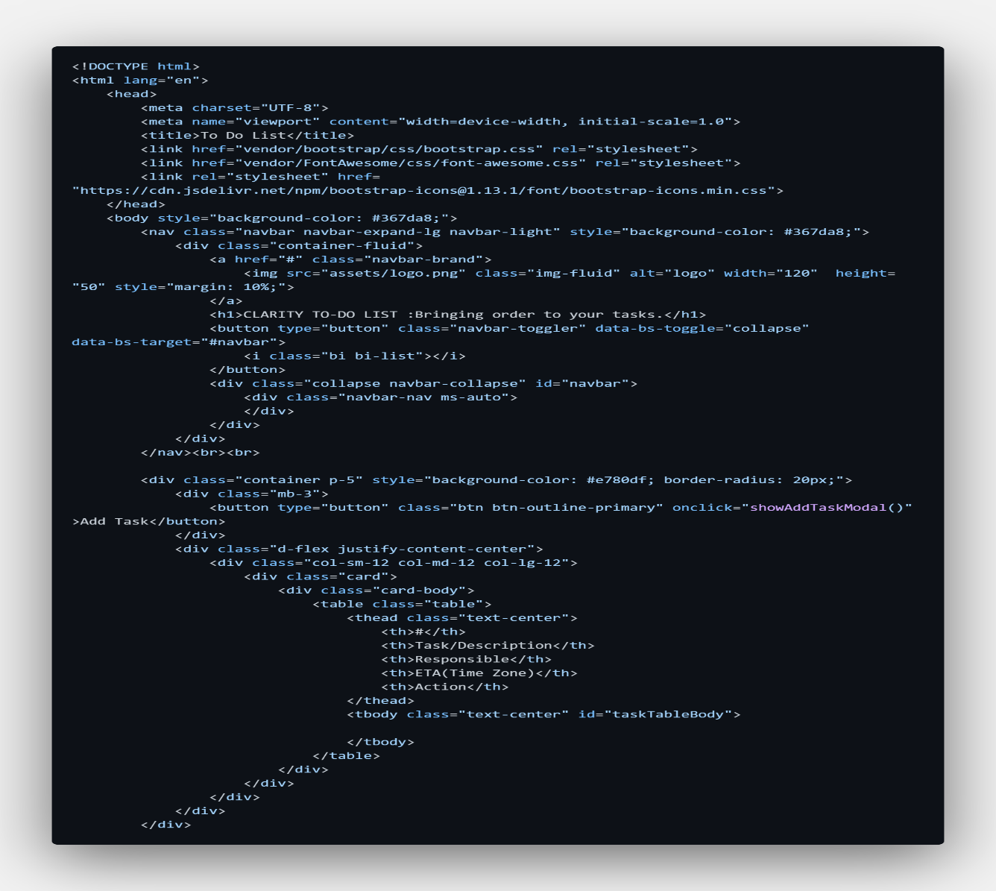
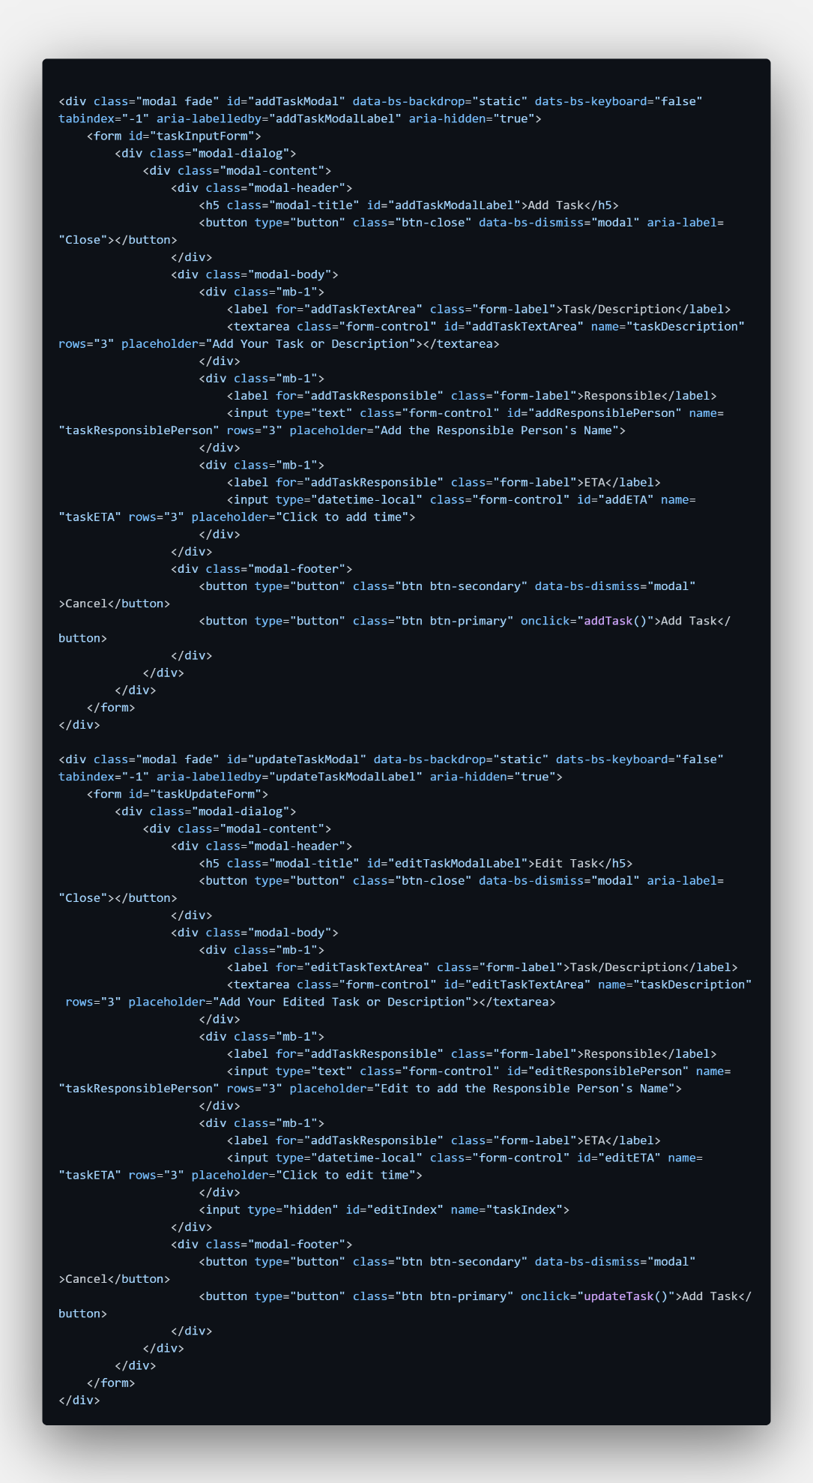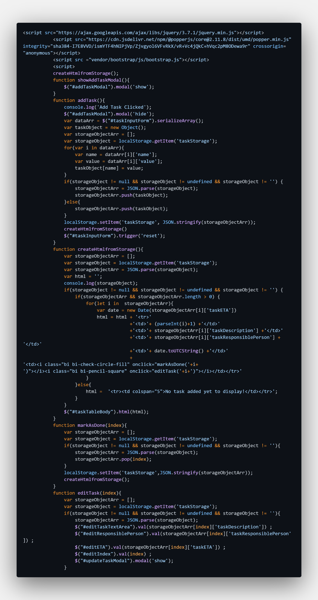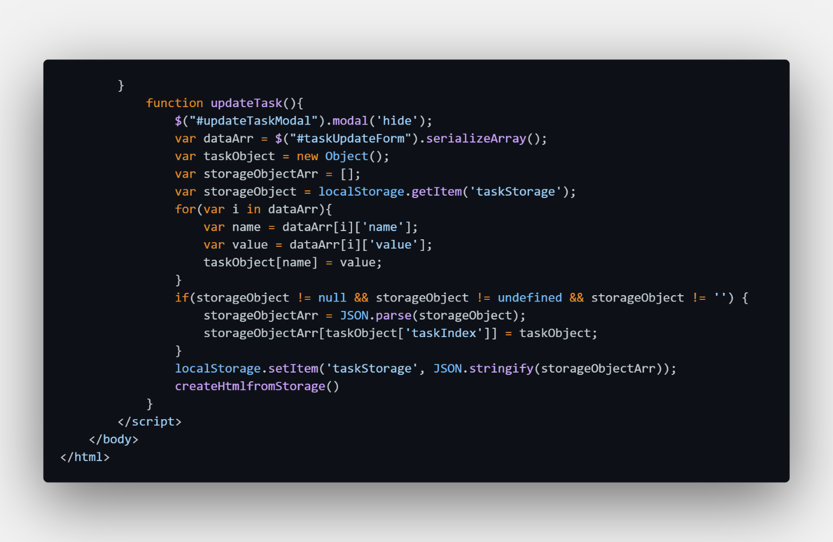

The provided code is a single HTML file containing embedded CSS (via Bootstrap and inline styles) and JavaScript (using the jQuery library). It creates a simple but effective to-do list application.
The application's functionality is handled entirely on the client side. It allows users to add new tasks, edit existing ones, and mark tasks as done, which removes them from the list. To ensure data persistence between user sessions, the application leverages the browser's localStorage API, storing all tasks as a JSON string.
The HTML structure consists of a navigation bar for the title, a main container for the task list, and two Bootstrap modals: one for adding new tasks and another for editing existing ones. The JavaScript code defines functions to handle all user interactions, such as showing modals, serializing form data into task objects, updating the localStorage, and dynamically re-rendering the task table in the user interface.

RESULTS AND OUTPUTS
HOME PAGE:
This is the initial view of the "CLARITY TO-DO LIST" application upon loading. It features the main title in the navigation bar and the task container below.
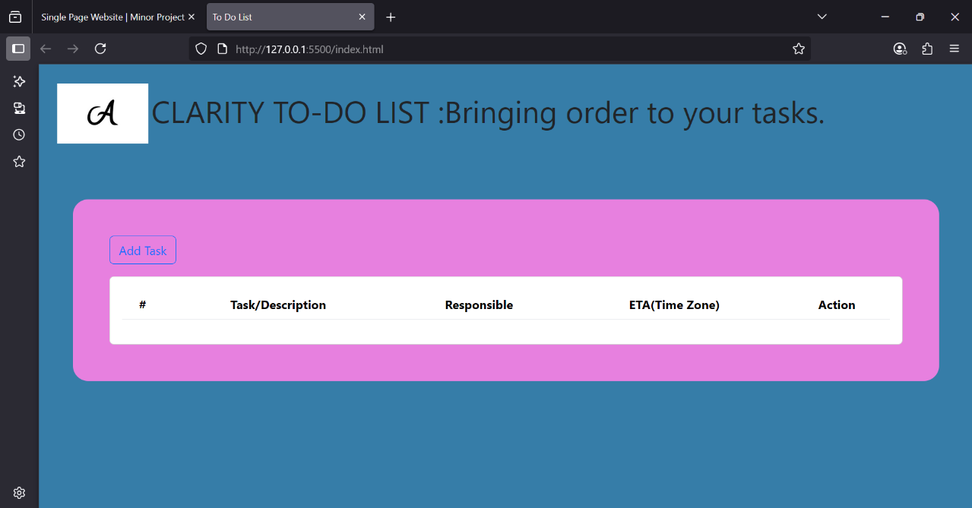
ADD TASK FORM:
When the user clicks the "Add Task" button, a modal dialog appears, overlaying the main page. This form provides input fields for the "Task/Description," "Responsible" person, and the "ETA" (Estimated Time of Arrival/Completion).
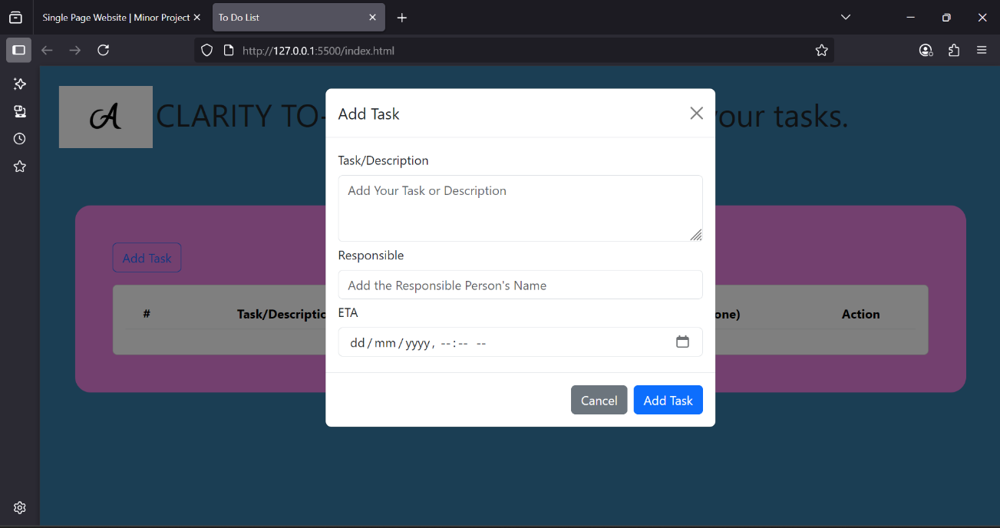

FILLING THE DETAILS IN THE ADD TASK FORM:
The user enters the details for a new task. For example, "Meeting" for the description, "Ananya" as the responsible person, and selects a specific date and time for the ETA.
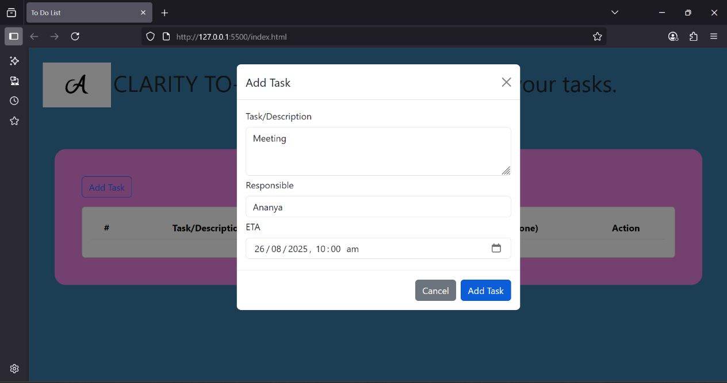
DISPLAYING THE TASK DETAILS ON THE SCREEN:
After the user clicks the "Add Task" button in the modal, the modal closes, and the main task list is updated instantly. The newly added task now appears as a row in the table, showing all details that were entered.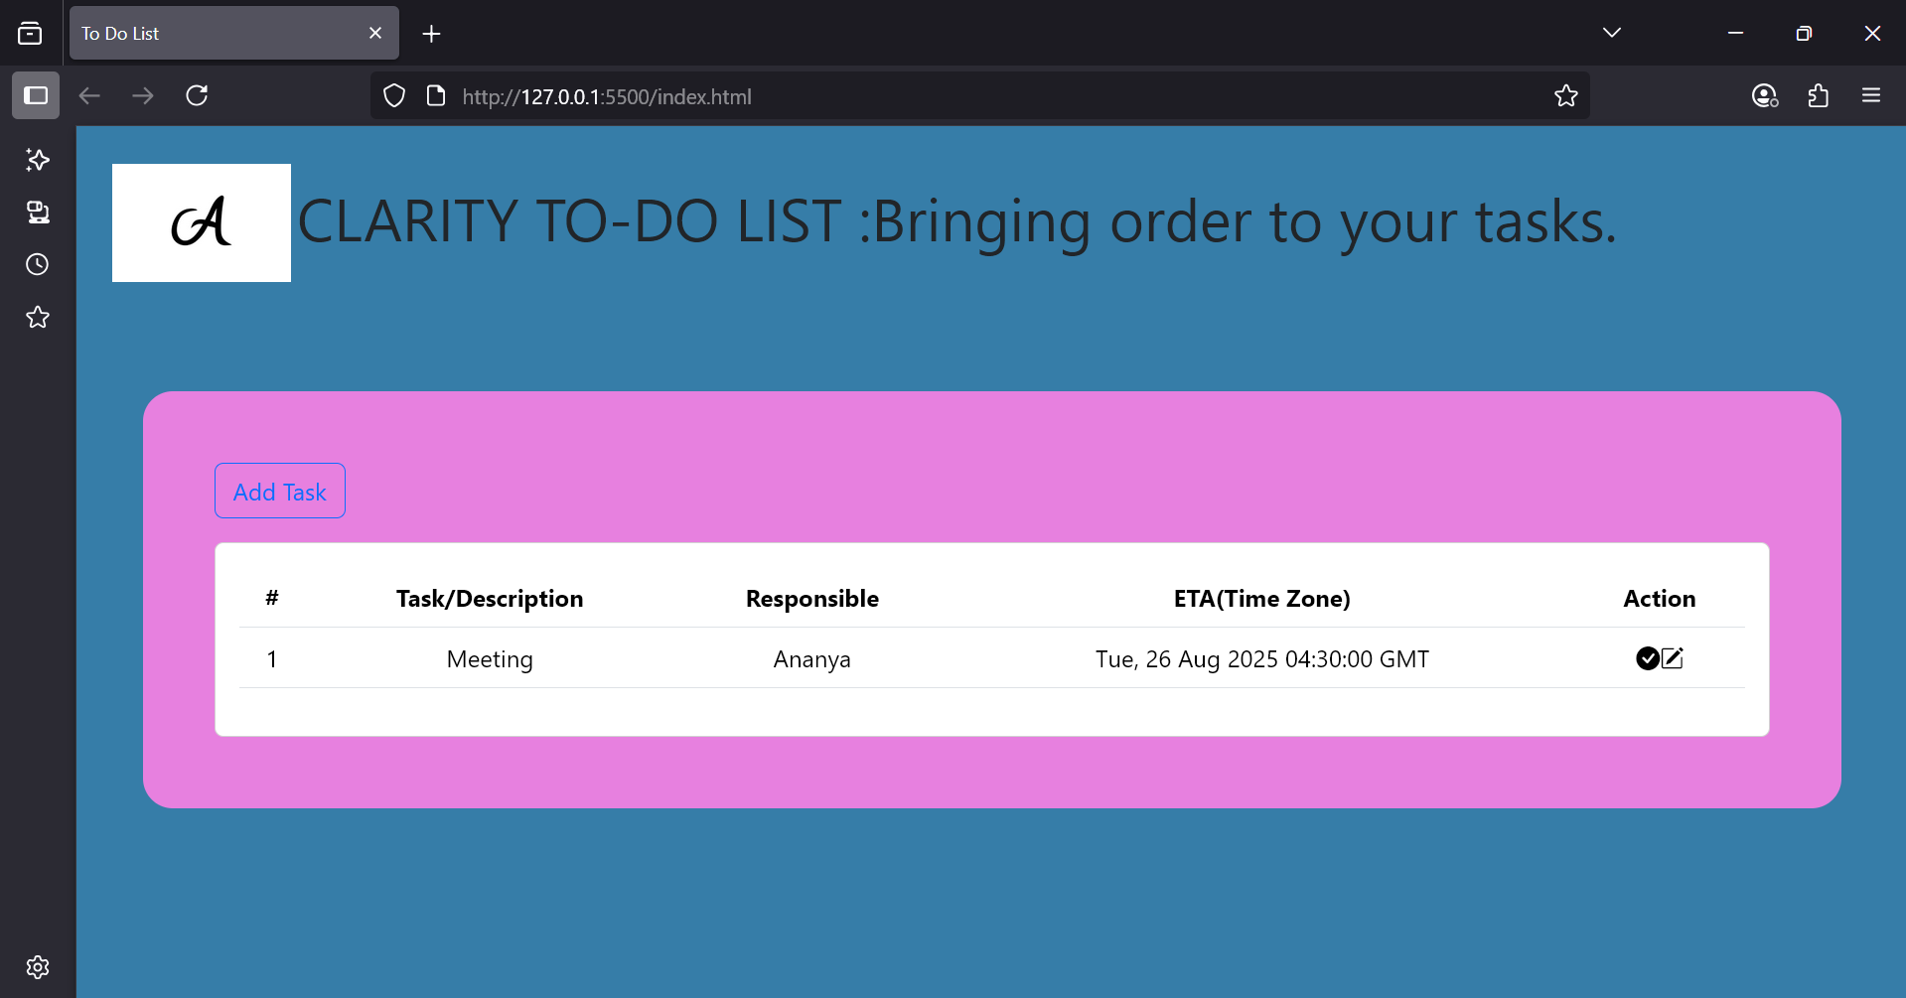

MORE TASKS ADDED AND DISPLAYED ON THE SCREEN:
Users can repeat the process to add multiple tasks. Each new task is appended to the list, creating an organized view of all pending items.
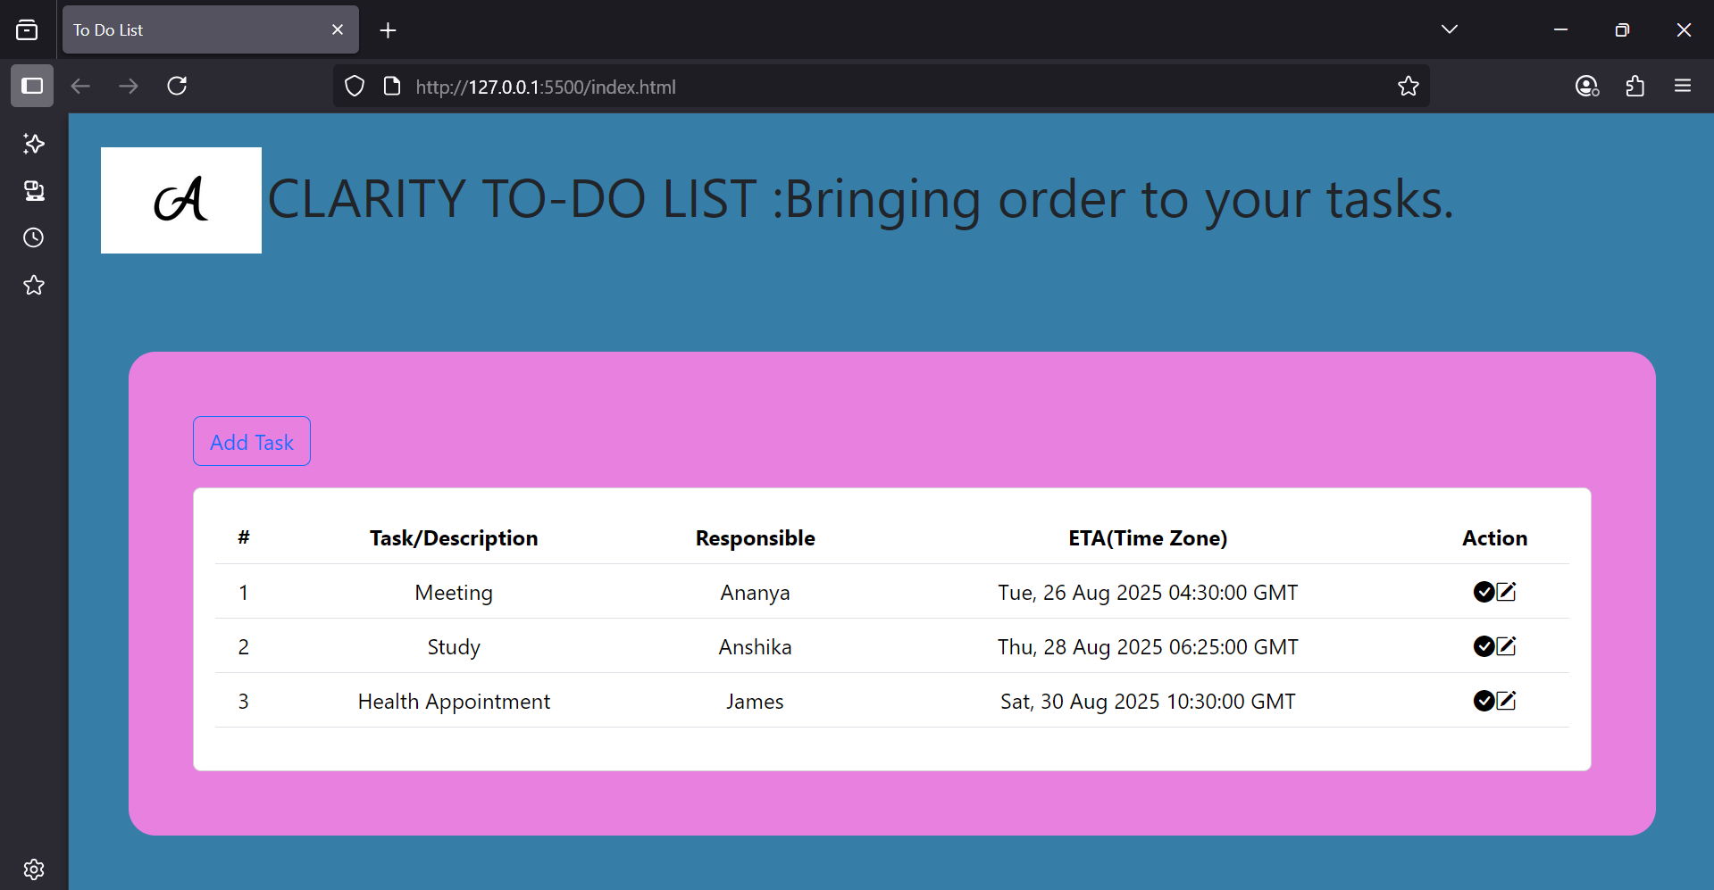
EDITING OF A TASK DETAILS:
To edit a task, the user clicks the pencil icon (bi-pencil-square) in the "Action" column for that specific task. This action opens the "Edit Task" modal, which comes pre-populated with the existing details of that task, ready for modification.
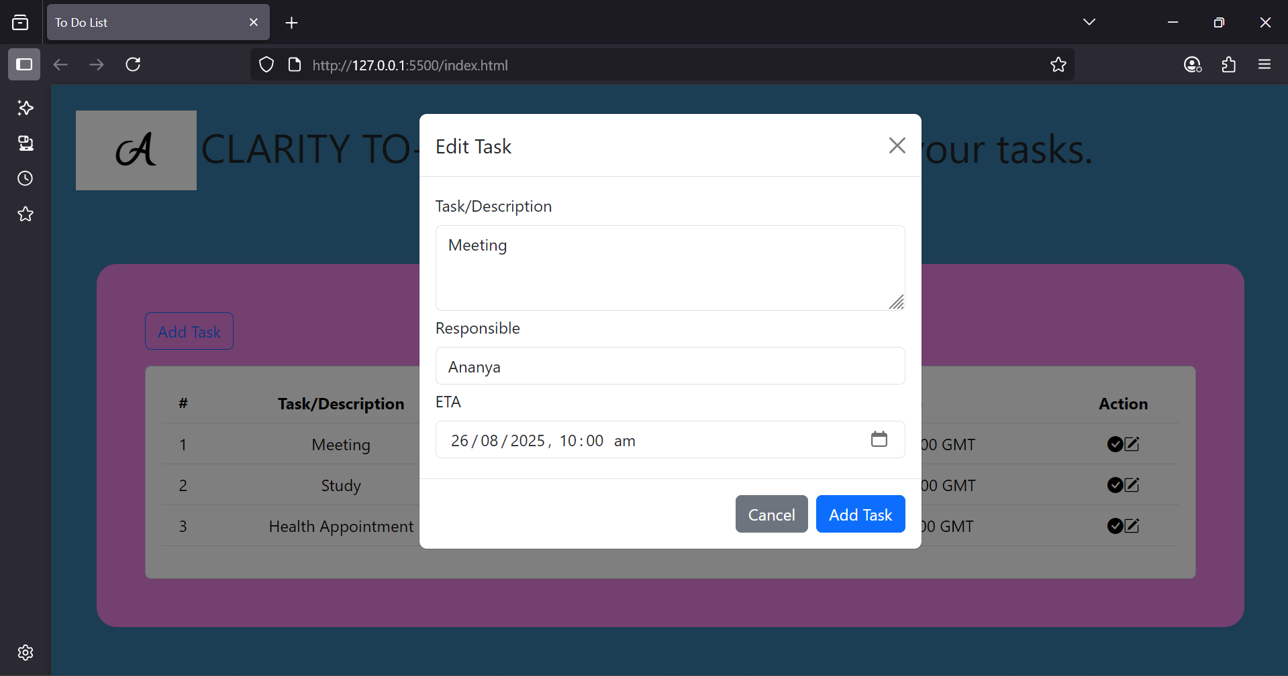
REFLECTED THE EDITINGS ON THE WEBPAGE DISPLAY:
After making changes in the "Edit Task" modal and clicking the "Add Task" (update) button, the modal closes. The task list on the main page is immediately updated to reflect the new information.
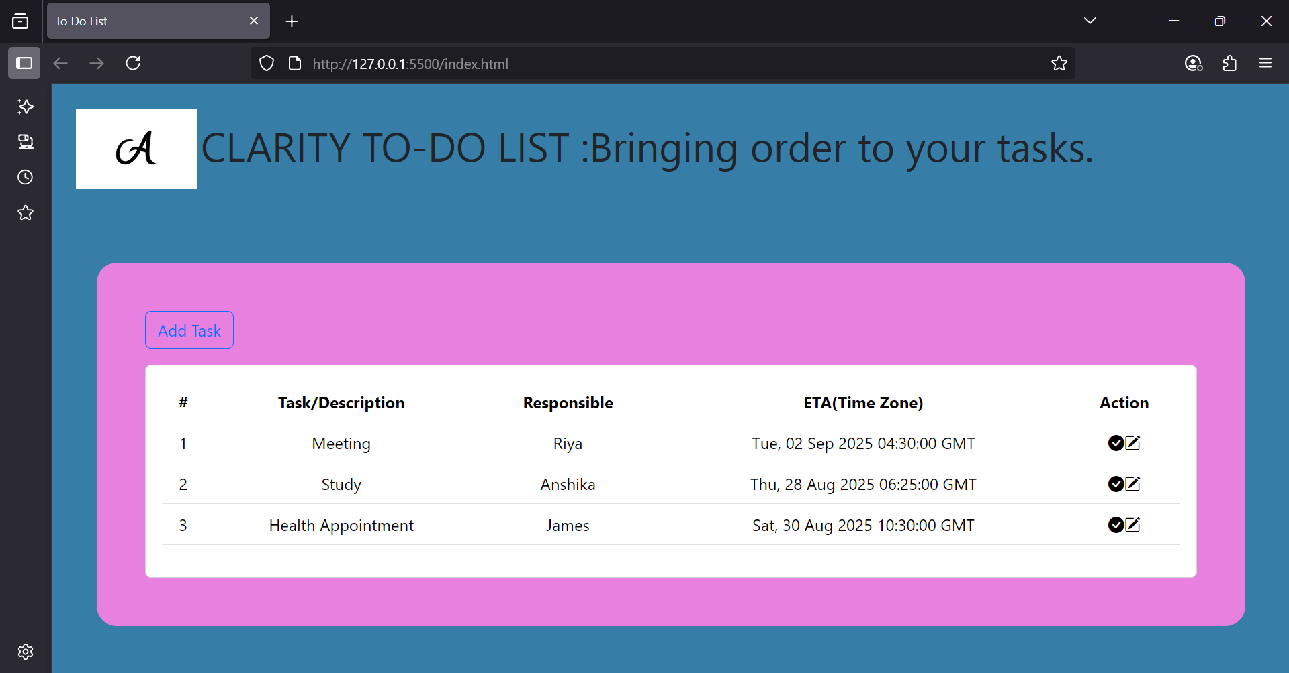

TASK COMPLETED AND REMOVING FROM DISPLAY:
When a task is completed, the user can click the checkmark icon (bi-check-circle-fill). This action removes the task from the list, signifying that it is done. The display updates in real-time to show the remaining tasks.
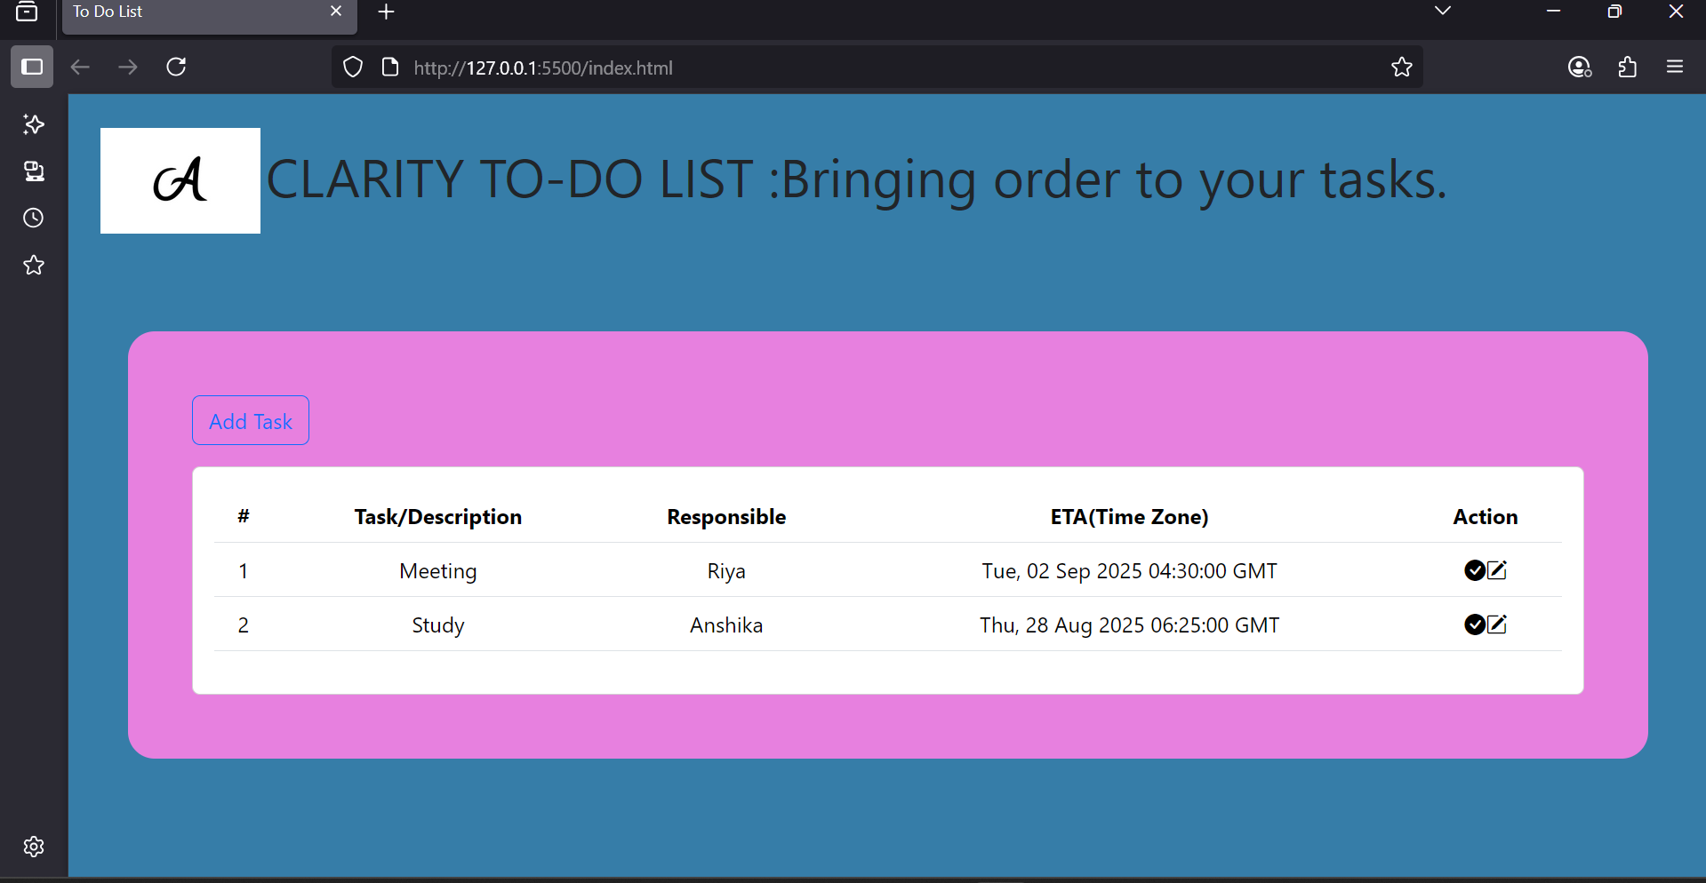
NO TASKS ARE PRESENT TO DISPLAY:
Once all tasks have been completed and removed from the list, the application returns to its initial empty state. The table again displays the "No task added yet to display!" message.
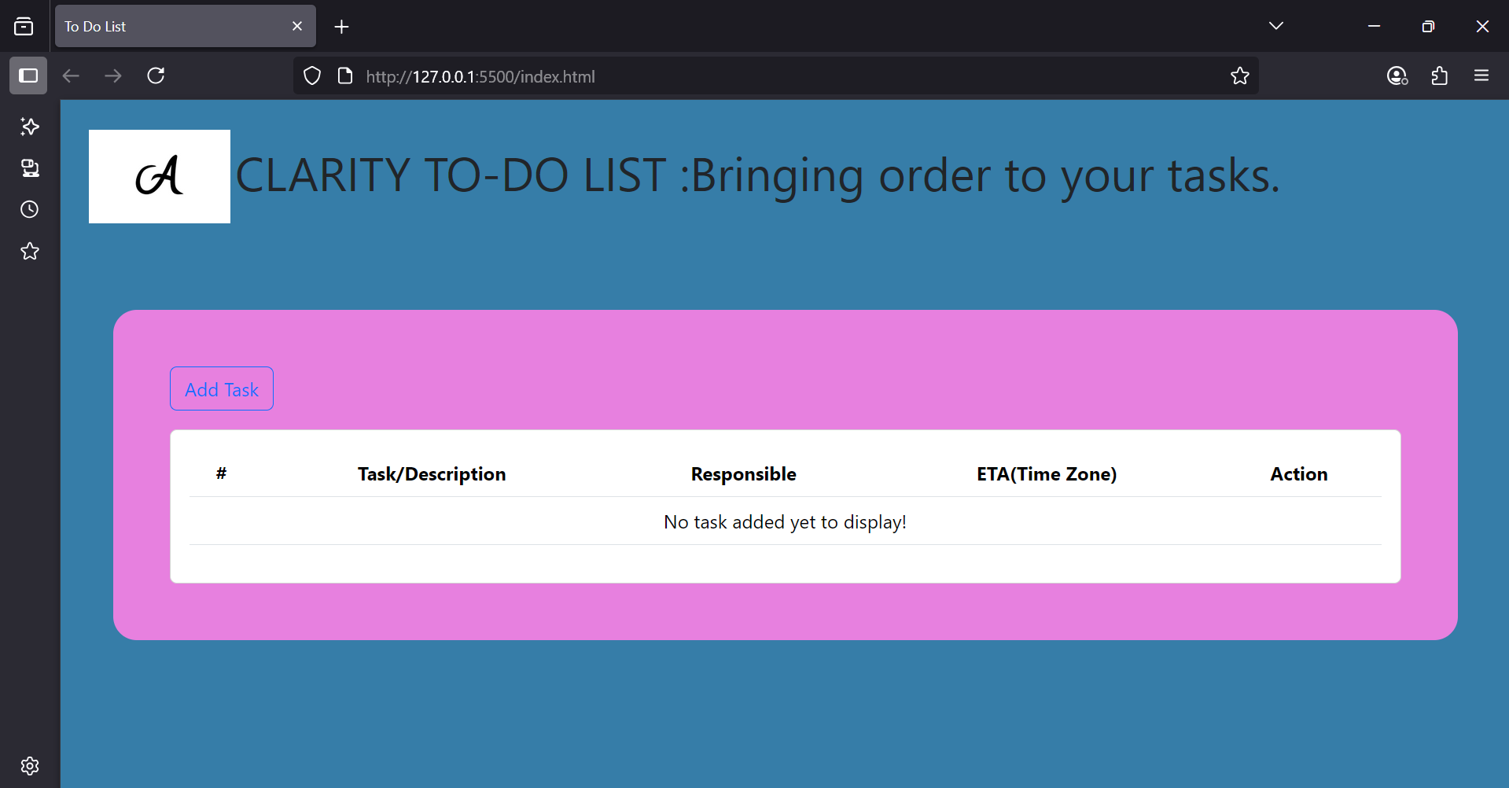
CONCLUSION
In conclusion, the development of the "CLARITY TO-DO LIST" application using HTML, Bootstrap, JavaScript, and jQuery has resulted in a versatile and user-friendly task management solution. By leveraging these technologies, we have successfully created a responsive and interactive To-Do list that empowers users to organize their tasks efficiently. Through careful planning and meticulous implementation of the HTML structure, Bootstrap components, and JavaScript functionality, we have ensured a seamless user experience across various devices and screen sizes.
The utilization of jQuery simplified DOM manipulation and event handling, contributing to the overall efficiency of the application. Furthermore, the integration of the browser's local storage provides a crucial data persistence feature, making the tool reliable for everyday use. Moving forward, continued iteration and refinement based on user feedback will further enhance the To-Do list's usability and effectiveness, cementing its role as a valuable tool for personal and professional task management.

